PataMtaani App

PataMtaani is both a web and a mobile app which provides a modern platform for vendors/businesses to sell, their products in their areas of residence and immediate neighborhood.

I Francis Mwendwa Mbatha id no 29440457 I am the developer and the owner of the application.

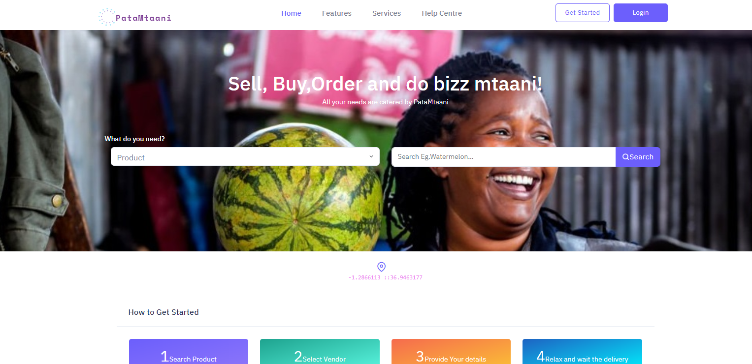

Pata Mtaani Main Features

The Pata Mtaani app comes with ready-to-use services that are completely easy-to-use for any user, even for a beginner.

#### **Convenient & Products**

Pata Mtaani helps you buy and sell household products and services just within your area of residence and your immediate neigbors

#### **Convenience of services**

Pata Mtaani helps you buy and sell all types of services just within your area of residence and your immediate neigbors

#### **Merket Analysis**

Pata Mtaani app will do a market analysis of your area of residence and, give the data back the vendors on the best products and services to sell.

#### **Seller and Buyer interaction**

Pata Mtaani helps you buy and sell household products and services just within your area of residence and your immediate neigbors

#### **Variety of Payment Methods**

We have more than nine (4) payment methods to and currency convertion capabilities.

#### **Free Delivery**

Pata Mtaani has completely catered all the delivery needs.